 | Occupational health and Safety (OHS) Management System | Document Ref. No | OHS 8.3.F1
 | Display Screen Equipment (DSE) Workstation Checklist / Assessment Form | Author | CFHS
 |  | Version | 01
 |  | Issue Date | 01/04/2024
 |  | Review Date | 01/04/2027

Name: |  | Work Style:  (Fixed Base / Agile Flexible / Home)
Job Title /  Service: |  | Line Manager Name:
Date: |  | User Dominant Hand | Left | Right
Assessed By: |  | Further Actions:  (Complete actions table as required) | Yes | No

The DSE ASSESSOR should work through the checklist with the USER, detailing Yes or No against each individual risk factor and any findings or actions required in the comment’s column. Once completed, this form should be forwarded directly to the individual users’ manager so that any immediate issues can be resolved.
The MANAGER should ensure that all employees who work with DSE comply with relevant legislative requirements and best practice. Review and identify actions and implement, so far as is reasonably practicable. Obtain assistance from Facilities, IT or the Corporate Fire, Health, and Safety Team, etc. as required and retain documentation for audit purposes.
- Yes: No issues; no further action required.
- No: Answers may require investigation and/or remedial action (space for further comments in Section 7).
- Remedial Actions: should be recorded in the ‘Comments’ column and guidance provided to User to address concerns.
- Manager: Follow up check later to ensure actions have been taken and have resolved the issue

Section 1: Display Screen (DSE Assessor and Users)
Risk Factor | Yes | No | Things to consider | Comments
Are the characters clear and readable?  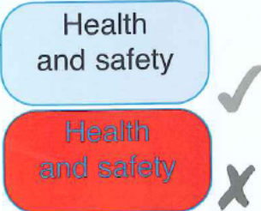 |  |  | Make sure the screen is clean and cleaning materials are made available.
Is the text size comfortable to read? |  |  | Software settings may need adjusting to change text size.
Is the image stable, i.e., free of flicker and jitter? |  |  | Try using different screen colours to reduce flicker, e.g., darker background, and lighter text
Is the screen’s specification suitable for its intended use? |  |  | For example, intensive graphic work or work requiring fine attention to small details may require large display screens.
Is the brightness and/or contrast adjustable? |  |  | Separate adjustment controls are not essential, provided the user can read the screen easily at all times.
Does the screen swivel and tilt?  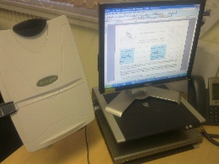  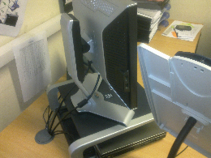 |  |  | Note: Standard monitor screens are height adjustable and have an integrated tilt facility, (see photographs). As they are lightweight, they can also be easily swivelled / adjusted to improve positioning further to assist the User.  However, you may need to replace the screen if:  - Adjustment facilities are missing, faulty or unsatisfactory.  - Work is intensive and/or the User has problems getting the screen to a comfortable position
Is the screen free from glare and reflections?  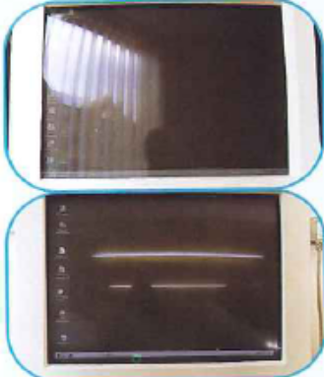 |  |  | You might need to utilise or install window coverings, move the screen or even the desk and/or shield the screen from the source of reflections.  Screens that use dark characters on a light background are less prone to glare and reflections.
Are adjustable window coverings provided and in adequate condition? |  |  | Check that blinds work. Blinds with vertical slats can be more suitable than horizontal ones.  If these measures do not work, consider anti-glare screen filters as a last resort, and seek specialist guidance.

Section 2: Keyboards (DSE Assessor and Users
Risk Factor | Yes | No | Things to consider | Comments
Is the keyboard separate from the screen? |  |  | This is a requirement unless the task makes it impracticable (e.g., where there is a need to use a portable laptop for short duration work).
Does the keyboard tilt? |  |  | Utilisation of keyboard legs or alternate angle support.
Is it possible to find a comfortable keying position?  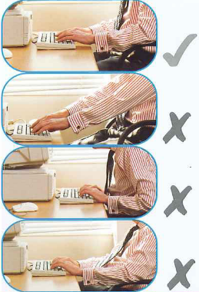 |  |  | Try pushing the display screen further back to create more room for the keyboard, hands, and wrists.  Users of raised keyboards may need a wrist rest.
Does the user have good keyboard/keying technique? |  |  | Ensure users hands are not angled up at the wrist, overstretching fingers, or striking keys too hard.
Are the characters on the keys easily readable? |  |  | Keyboards should be kept clean. If characters still cannot be read, the keyboard may need modifying or replacing.  Use a keyboard with matt finish to reduce glare and/or reflection.

Section 3: Mouse, Trackball etc. (DSE Assessor and Users)
Risk Factor | Yes | No | Things to consider | Comments
Is the device suitable for the task it is used for? |  |  | If the user is having problems, try a different device. The mouse and trackball are general-purpose devices suitable for many tasks, and available in a variety of shapes and sizes.  Alternative devices like touch screens may be better for some tasks (but can be worse for others).
Is the device positioned close to user?  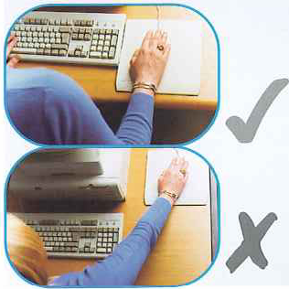 |  |  | Most devices are best placed as close as possible, e.g., right beside the keyboard.  Training may be needed to:  - Prevent arms over-reaching.  - Inform users not to leave their hand on the device when it is not being used.  - Encourage a relaxed arm and straight wrist.
Is there support for the device user’s wrist and forearm? |  |  | Support can be gained from the desk surface or arm of a chair. If not, a separate supporting device may help.  The user should be able to find a comfortable working position with the device.
Does the device work smoothly at a speed that suits the user? |  |  | See if cleaning is required (e.g., of mouse ball and rollers).  Check the work surface is suitable.  A mouse mat may be needed.
Can the user easily adjust software settings for speed and accuracy of pointer? |  |  | Users may need training in how to adjust device settings.

Section 4: Software (DSE Assessor and Users)
Risk Factor | Yes | No | Things to consider | Comments
Is the software suitable for the task? |  |  | Software should help the user carry out the task, minimise stress and be user-friendly.  Check users have had appropriate training in using any installed software.  Software should respond quickly and clearly to user input, with adequate feedback, such as clear help messages.

Section 5: Furniture (DSE Assessor and Users)
Risk Factor | Yes | No | Things to consider | Comments
Is the work surface large enough for all the necessary equipment, papers, etc?  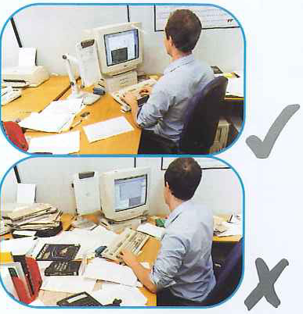 |  |  | Create more room by moving printers, reference materials, etc elsewhere.  If necessary, consider providing new power and telecoms sockets so equipment can be moved.  There should be some scope for flexible rearrangement.  Note: Keep desks tidy, clear clutter / ensure good housekeeping standards are maintained.
Can the user comfortably reach all the equipment and papers they need to use? |  |  | Rearrange equipment, papers etc. to bring frequently used items within easy reach.  A document holder may be needed, positioned to minimise uncomfortable head and eye movements.
Are surfaces free from glare and reflection? |  |  | Consider mats or blotters to reduce reflections and glare.
Is the chair suitable, stable and does it have the following?  - Seat back, height and tilt adjustment.  - Seat height adjustment.  - Swivel mechanism.  - Castors or glides. |  |  | The chair may need repairing or replacing if the user is uncomfortable or cannot use the adjustment mechanisms.
Is the chair adjusted correctly?  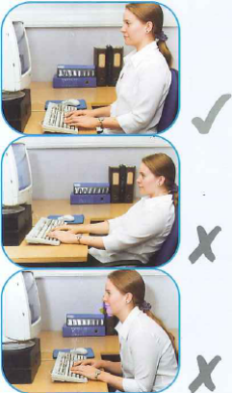 |  |  | The user should be able to carry out their work sitting comfortably.  Consider training the user in how to adopt suitable postures while working.  The arms of chairs can stop the user getting close enough to use the equipment comfortably.  Move any obstructions from under the desk.
Is the small of the back supported by the chair’s backrest? |  |  | The user should have a straight back, supported by the chair, with relaxed shoulders.
Are forearms horizontal and eyes at roughly the same height as the top of the screen? |  |  | Adjust the chair height to get the user’s arms in the right position, then adjust the screen height, if necessary.
Are feet flat on the floor, without too much pressure from the seat on the backs of the legs? |  |  | If not, a footrest may be needed.

Section 6: Environment (DSE Assessor and Users)
Risk Factor | Yes | No | Things to consider | Comments
Is there enough room to change position and vary movements? |  |  | Space is needed to move and stretch.  Consider reorganising the office layout and check for obstructions.  Cables should be tidy and not a trip or snag hazard.
Is the lighting suitable, e.g., not too bright, or too dim to work comfortably? |  |  | Users should be able to control light levels e.g., by adjusting window blinds or light switches.  Consider shading or repositioning light sources or providing local lighting e.g., desk lamps (but ensure lights do not cause glare by reflecting off walls or other surfaces).
Does the air feel comfortable? |  |  | DSE and other equipment may dry the air.  Circulate fresh air, if possible, plants may help.  Consider a humidifier if discomfort is severe.
Are levels of heat comfortable? |  |  | Can heating be better controlled?  More ventilation or air-conditioning may be required if there is a lot of electronic equipment in the room?  Or can users be moved away from heat source?
Are levels of noise comfortable? |  |  | Consider moving sources of noise, e.g., printer, away from the user. If not, consider soundproofing.  Consider how to address sources of noise from meetings and from colleague(s) singly or severally.

Section 7: Further Comments (DSE Assessor & User)
Further Comments (DSE Assessor and User)

Section 8: To be completed by the Manager.
To be completed by the Manager
- Review checklist with the User and discuss issues, specify actions to address concerns.
- Ask user if the checklist has covered all of the problems they may have whilst working with their DSE.
- Ask user if they have experienced any discomfort or other symptoms which they attribute to working with their DSE.
- Ask if the user has been advised of their entitlement to eye and eyesight testing.
- Ask if the user takes regular breaks working away from DSE.

Detail issues identified and actions to rectify:
Ref. | Issue: | Action to Address: | Responsible Person: | Target Date: | Completion Date:
1
2
3
4
5

